

5 – Web vs Software Development:

**Web developer:**

* Web developers built those sites, making sure they functioned properly and performed in ways that allowed for a great user experience.

**Web Designer vs Web Developer:**

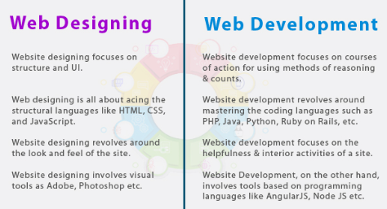

**Most common language:**

* HTML (Hypertext Markup Language) --> give a structure of a website
* CSS (Cascading Style Sheets)
* JavaScript

**MERN Stack:**

* A tech stack refers to a set of tools, programming languages, and technologies (frameworks, libraries) that one needs to know to build a website. One of the popular web stacks is the MERN Stack
* MERN stands for MongoDB, Express, React, and Node which make up the stack

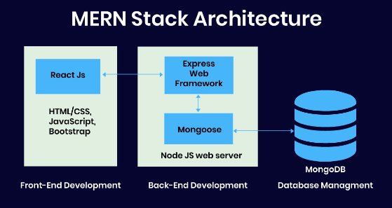 



**Software Development:**

* The process of creating, designing, coding, testing, and maintaining software applications, systems, or programs that serve specific purposes or solve particular problems.

**Software vs Web Development:**

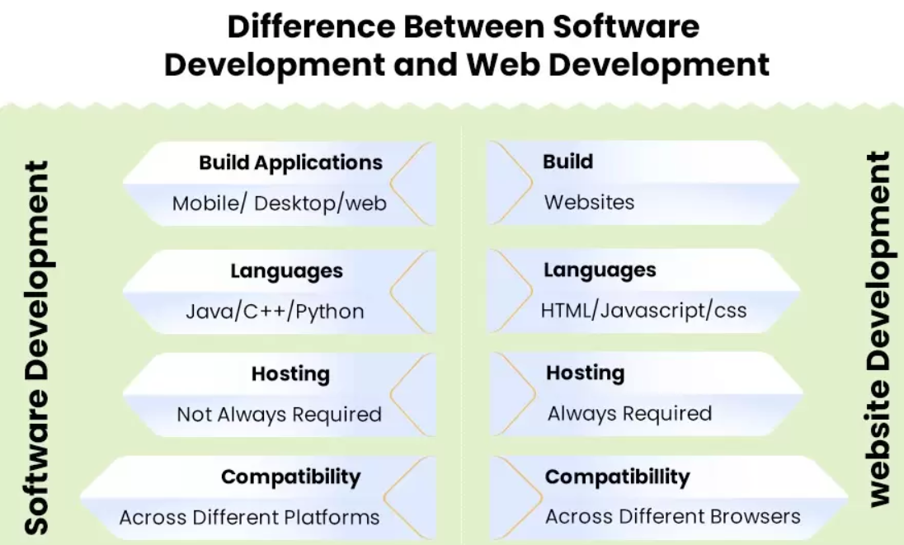

6 - File and Folder:

* File: A digital representation of data
* Folder: Container for files to categorize the data or files.
* To move: cut and paste
* To copy: copy and paste